8 BIT ADDITION

# EXP NO: 01

## AIM:

## To write an assembly language program to implement 8-bit addition using 8085 processor

## ALGORITHM:

1. Start the program by loading the first data into accumulator.
2. Move the data to a register.
3. Get the seconds data and load it into the accumulator.
4. Add the two register contents.
5. Check for carry.
6. Store the value of sum and carry in the memory location.
7. Halt.

## PROGRAM:

LDA 4500

MOV B,A

LDA 4501

ADD B

STA 4502

RST 1

## Input:

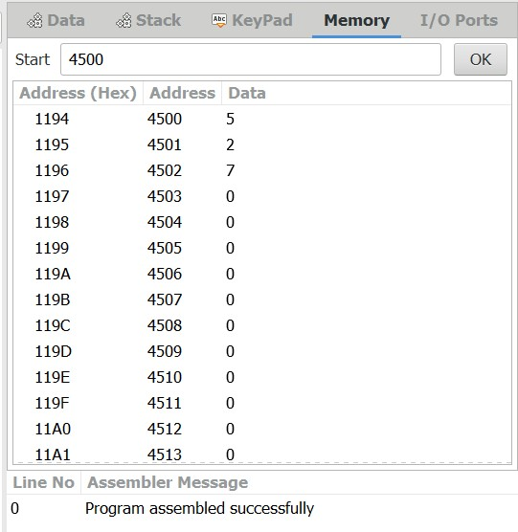

## OUTPUT:

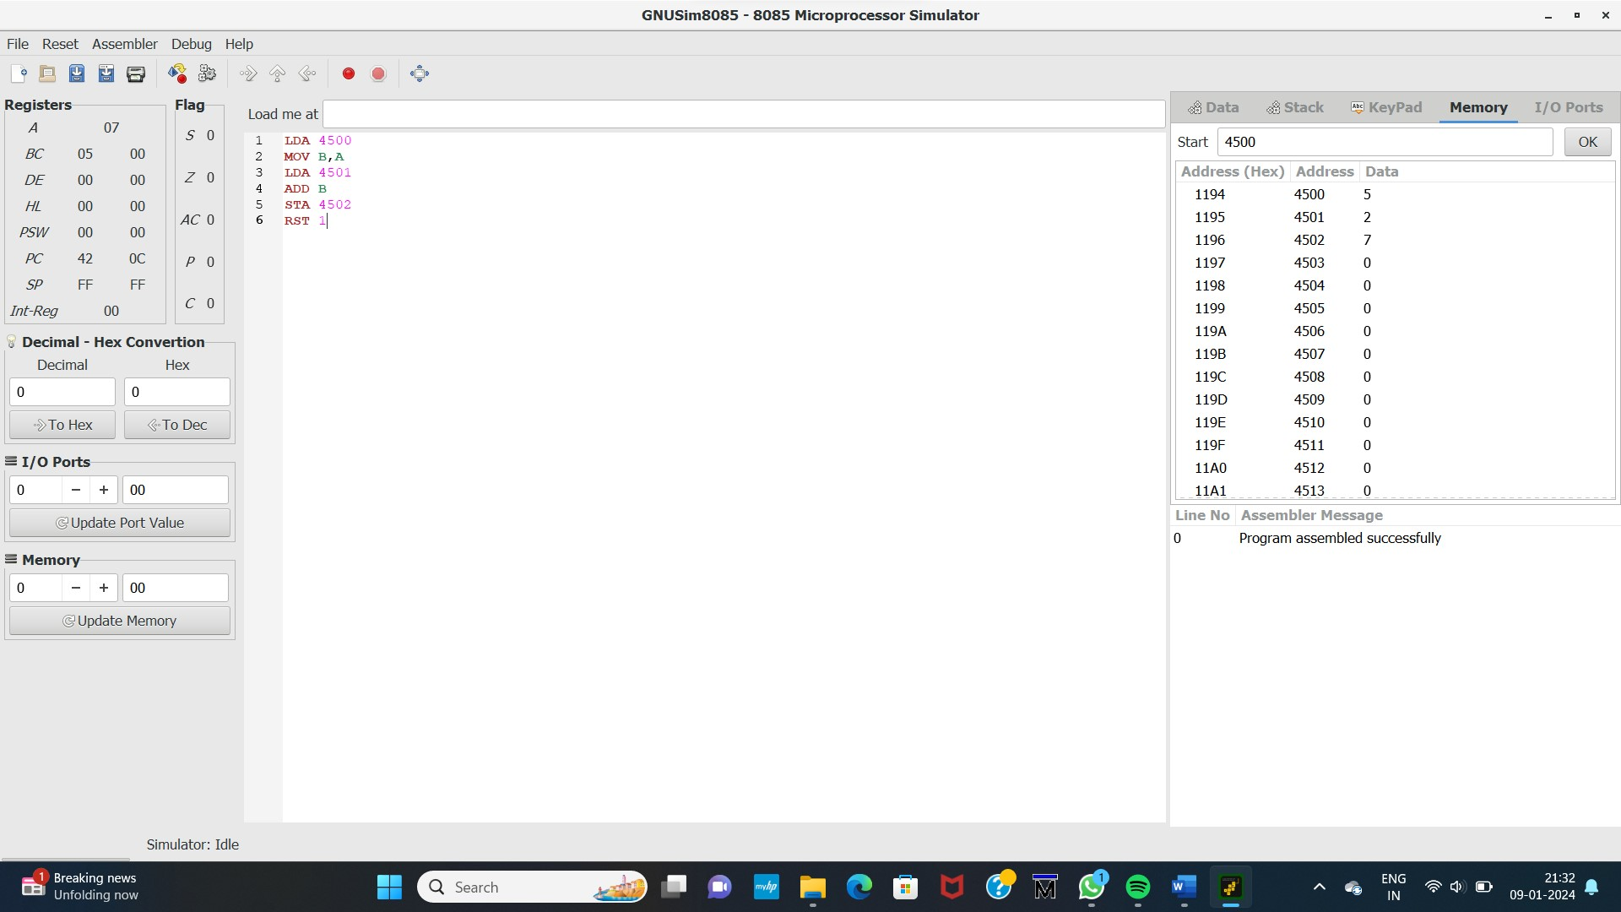

Result:

Thus the program was executed successfully using 8085 processor stimulator